

**1**

**=**

**2**

**Round 2: Calculations**

Complete the calculations: *(2 points for every correct answer)*

**x**

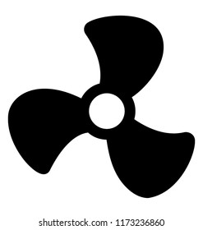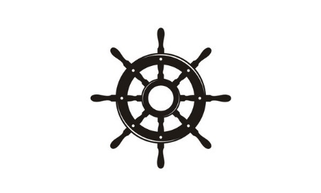

**=**

**+**

**5**

**3**

**+**

**x**

**=**

**x**

**)**

**-**

**(**

**=**

**20**

**=**

**=**

**÷**

**x**

**12**

**=**

**6**

**=**

**323**

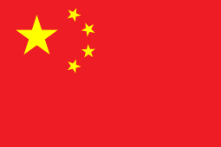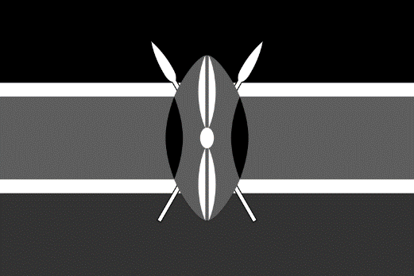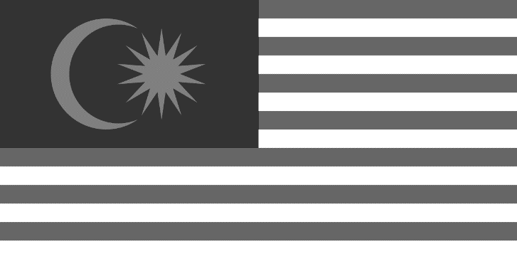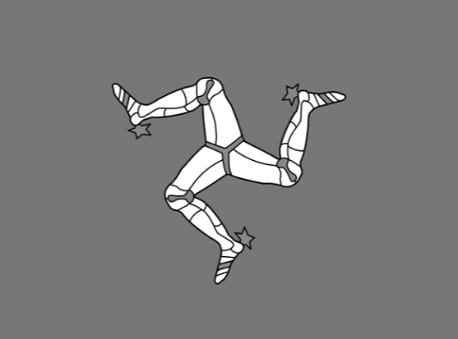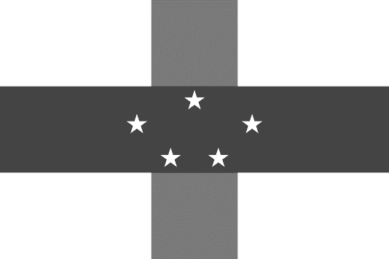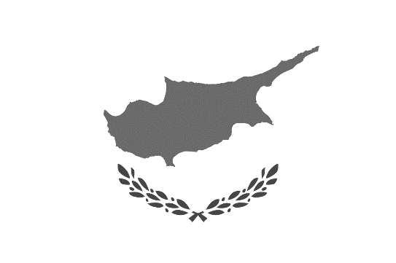

**Kenya**

**Reunion**

**Canada**

**China**

**Pakistan**

**Dutch Antilles**

**Malaysia**

**Cyprus**

**Nepal**

**Isle of Man**

Names:

Identify the flags: *(2 points for every correct answer)*

**Round 1: Black and White National Flags**